**38. Design NFA using a simulator to accept the input string “bbc” ,”c”,and ”bcaaa”. AIM:** To design a NFA using a simulator to accept the input string “bbc” ,”c”,and ”bcaaa”. **TRANSITION DIAGRAM**

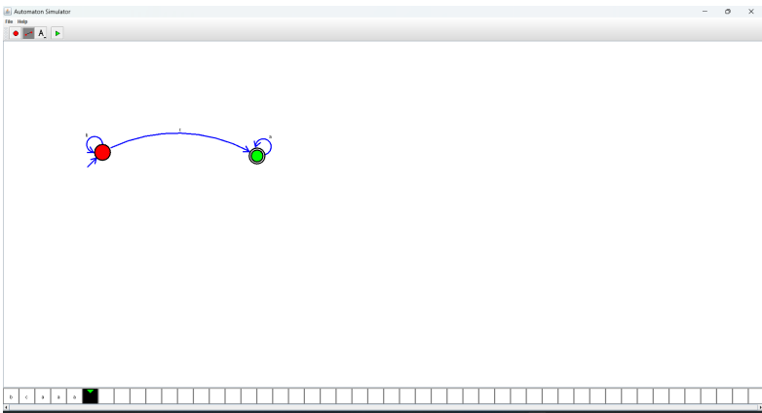

**RESULT:** Hence designing NFA using a simulator to accept the string bbc, c and bcaaa